Publication Date: April 2013
Publicity Contact: David Hawk, Publicity Manager, Food and Drink
Phone: 415.537.4276

E-mail: david_hawk@chroniclebooks.com

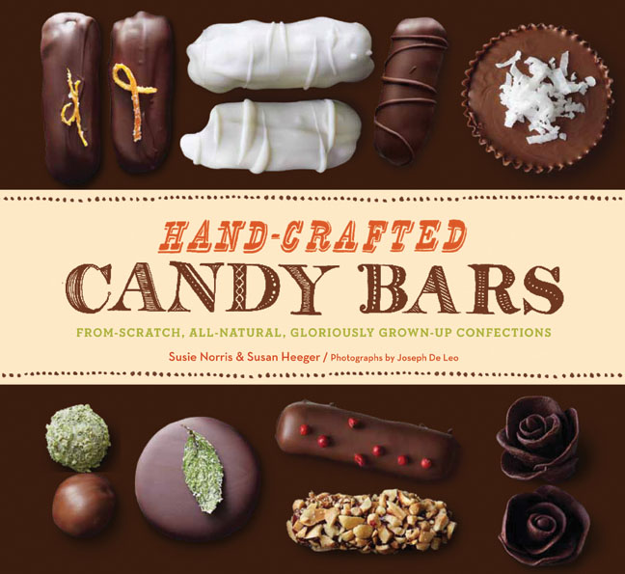 | Hand-Crafted Candy Bars  From-Scratch, All-Natural, Gloriously Grown-Up Confections  By Susie Norris & Susan Heeger  Photographs by Joseph De Leo  ISBN 978-1-4521-0965-7| $24.95
It’s no wonder fine restaurants have been adding homemade candy bars to their dessert menus. Using high-quality ingredients and no preservatives, these sweet treats rival even the most indulgent desserts and are a far cry from the processed bars we grew up with.

Now, you can rediscover the favorite confectionery flavors of your youth in your own kitchen – peanut butter and chocolate; nougat and nuts; mint and dark chocolate; almond and coconut—in cleverly reimagined recipes from authors Susie Norris and Susan Heeger.

Chocolate Butter-Toffee Snaps, the perfect marriage of butter and sugar; Over the Moon, full of malted nougat goodness; and crunchy Cocoa-Nib Caramel Cookie Sticks are delicious homages to the classics. And the authors go a step further by adding modern ingredients like green tea, chipotle pepper, sea salt, or tarragon, resulting in totally new candy sensations.

Recipes for basics, including caramel, ganache, fudge, marshmallow, nougat, toffee, and marzipan, give you the building blocks to re-create your childhood favorites. And you can also use them to create your own signature candy bar (look for the inspiring suggestions in the mix-and-match flavor chart to get started).

Be happy. Eat candy.

*****
Susie Norris is an author, artisan chocolatier, pastry chef, and culinary school instructor. Her award-winning chocolate business, Happy Chocolates, has been featured on Food Network and in More magazine. She recently taught baking and pastry arts at Le Cordon Bleu College of Culinary Arts and Sur La Table in Los Angeles. Her favorite commercial candy bars are Snickers and Twix. Susan Heeger is a longtime book, magazine, and newspaper feature writer with a specialty in food, garden, design, home, and lifestyle stories. She co-authored From Seed to Skillet, an edible gardening primer and cookbook (also published by Chronicle Books), and is a contributing editor for Garden Design magazine. Her favorite commercial candy bars are Milky Way and Snickers.

*****

About Chronicle Books

One of the most admired and respected publishing companies in the U.S., Chronicle Books was founded in 1967 and over the years has developed a reputation for award-winning, innovative books. Recognized as one of the 50 best small companies to work for in the U.S. (and the only independent publisher to receive this award), the company continues to challenge conventional publishing wisdom, setting trends in both subject and format, maintaining a list that includes much admired illustrated books and gift products in design, art, architecture, photography, food, lifestyle, pop culture, and acclaimed children’s titles. Chronicle Books’ objective is to create and distribute exceptional publishing that’s instantly recognizable for its spirit, creativity, and value. For more information about Chronicle Books, visit www.chroniclebooks.com.

